**Real-Time, AI-Assisted Flame Stability Analysis: An Approach for**

**Flame Spray Pyrolysis**

**Jessica Pan**

**Argonne National Laboratory**

**Marius Stan**

**Mentor’s Signature: ____________________________________________________________**

**Abstract**

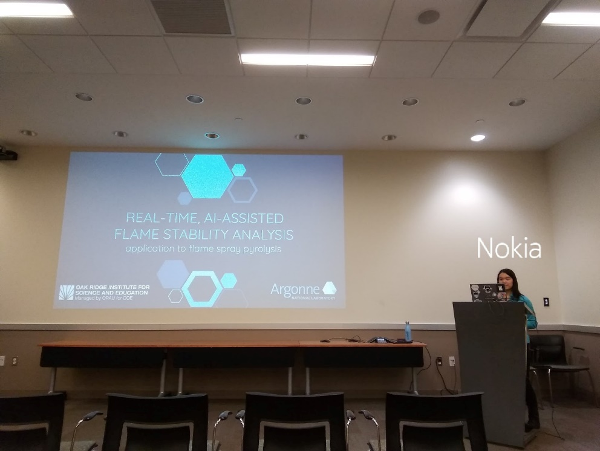

Figure 1: Jessica presenting her final project as a seminar in front of other Argonne researchers. Photographer: Blake Richey

Flame spray pyrolysis (FSP) is currently an experimental process used to synthesize nanoparticles through combusting a solvent. However, current limitations in the understanding of how to consistently achieve a stable flame is impeding the reliable production of particles using this method. Therefore, streamlining the flame spray process using machine learning and artificial intelligence on FSP video feed  to detect unstable flame conditions will contribute to fewer wasted resources as well as a safer working environment. To do so, we first determine a way to quantitatively decide whether or not the burner flame is stable. This method can be used to label data for use in both unsupervised and supervised learning techniques or applications, such as principal component analysis for image classification, respectively. In doing so, we can generate a real-time tracking of FSP flame conditions and alert users should an unstable flame state be achieved at any point in the synthesis process. This project can help the teams at MERF more efficiently optimize and manage flame spray pyrolysis.

**Real-Time, AI-Assisted Flame Stability Analysis: An Approach for Flame Spray Pyrolysis**

**Introduction**

Flame spray pyrolysis is a synthesis process used to make powder-like nanoparticles by combusting a solvent loaded with precursors [CITATION NEEDED]. These powders can then be used for a variety of applications, including manufacturing and nuclear energy. I will be using elements of image processing, computer vision, machine learning and artificial intelligence to study and optimize the use of flame spray pyrolysis.

**Project Description**

1. Purpose

The overall goal of Marius Stan’s team at Argonne National Laboratory is to create a cohesive team of humans and software to perform real-time optimization of the flame spray pyrolysis synthesis process, where data from experiments feeds a machine learning model, which in turn generates predictions for future trials. Thus, this creates a cycle of repeated learning and observations. Such an approach to meeting this vision can be largely physical and chemical. For example, Debolina Dasgupta was able to use computational fluid dynamics simulations as a means of exploring the MERF flame spray pyrolysis burner [CITATION NEEDED]. To better understand the breakup of the solvent mixture as it leaves the burner nozzle, she performs volume of fluids simulations which helps in incorporating actual physics in the spray description when performing simulations of the burner. [CITATION NEEDED]

The specific purpose and application of this project is to optimize burner flame stability of flame spray pyrolysis in near-real-time using a computer vision and artificial intelligence approach. This would allow for a program to autonomously learn from the process (without the need for hard-coded instructions) in a much more efficient and accurate manner when compared to its human counterparts.

1. Research Problem

Being an experimental process, flame spray pyrolysis may not produce the right or favorable yield of nanoparticles if the burner flame becomes unstable. This is because the completion of combustion of an unstable flame is uncertain, and thus solvent may leave the process without having combusted. [CITATION NEEDED] Not only does this waste precious time and resources, but can compromise the safety of the setup due to residue buildup of the unignited solvent. In detecting and lessening the frequency of unstable flame conditions in flame spray pyrolysis, a more efficient and safer work environment can be achieved.

1. Data Collection and Tools

The data behind this project consisted of 53 videos each with a length of approximately 10 seconds as well as expert classifications detailing whether or not the flame featured in each video clip is stable.

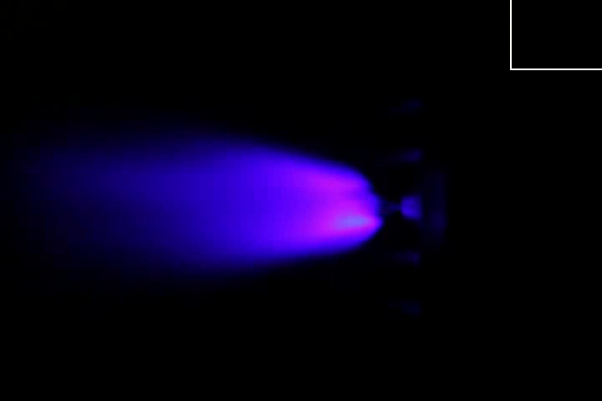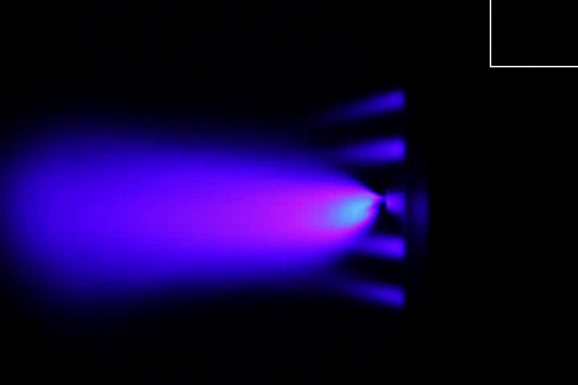

This project is coded primarily in Python, with extensive use of its Scikit-Learn, Scipy, and OpenCV libraries. TensorFlow and CUDA was also used to train the object detection classifier; resources offered in the EdjeElectronics TensorFlow-Object-Detection-API-

Tutorial-Train-Multiple-Objects-Windows-10 Github repository also aided greatly in producing my supervised learning results.

1. Methodology and Results
   1. Stability Classification

Flame stability classification is a necessary precursor to this project: there needs to be a way to classify the image of a flame in a way that is not entirely subjective.

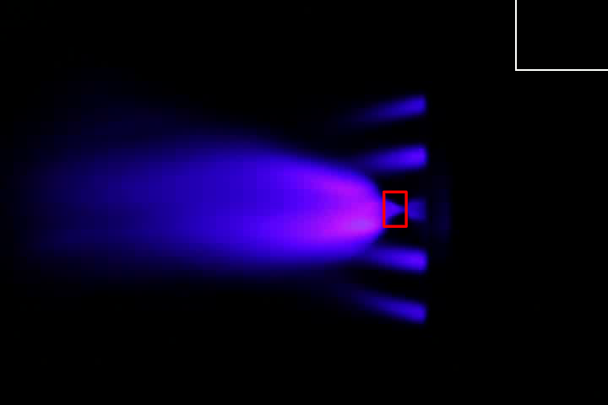 The my approach for quantitatively determining flame stability involved analyzing the pixels contained within a bounding box region of the burner flame. The pixels near 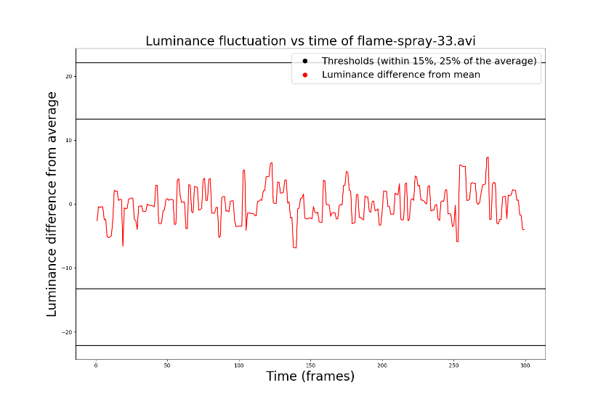the nozzle exhibited great changes in luminosity, or brightness, in unstable flames because there is a lot of flickering in that region. I averaged the luminosity of all the pixels in the bounding box across all of the frames 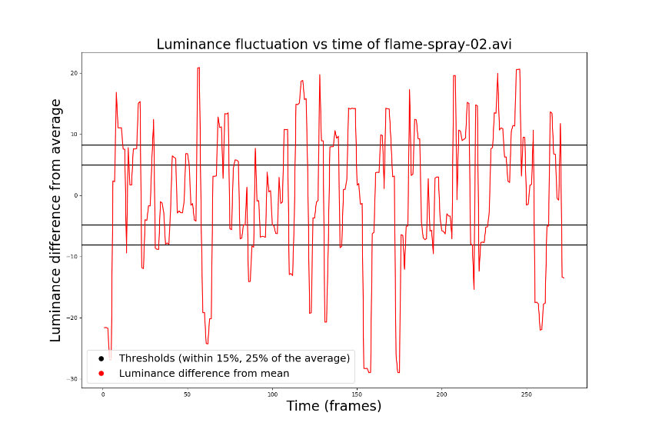of a video, and then plotted each frame’s difference in luminosity from that average. I also set threshold which were 15% and 25% of the average away from that average; if the fluctuation in luminosity crossed the 25% threshold, the video was given an ‘unstable’ classification. If, however, it only crossed the 15% threshold line, the video was given an ‘uncertain’ rating. Examples of this process as applied to stable and unstable flame videos are shown in figures [] and [].

To measure the efficacy of this method, I compared it to the accounts of 4 experts (to compensate for differences in opinion, I averaged all of them). 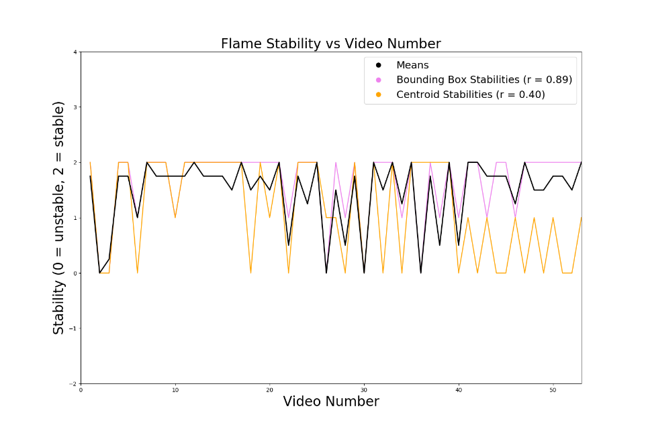The flame stability as measured with the bounding box approach performed well, with a correlation coefficient of 0.89. Therefore, that is the method I will be using in future analyses to label future datasets and classifications.

* 1. Unsupervised Machine Learning

After classifying the flame spray pyrolysis videos, I turned to an unsupervised machine learning approach to determine whether or not an algorithm was capable of finding features which differentiated stable and unstable flame properties. The original feature space was 1200-dimensional (consisting of the luminosity of every pixel in the bounding box of every frame), which, using principal component analysis (PCA), we were able to reduce down to merely 2 dimensions while still capturing 74% of the variance of the original data. By coloring the frames according to their assigned labels, we can see that it is possible to separate a region of ‘unstable’ frames.

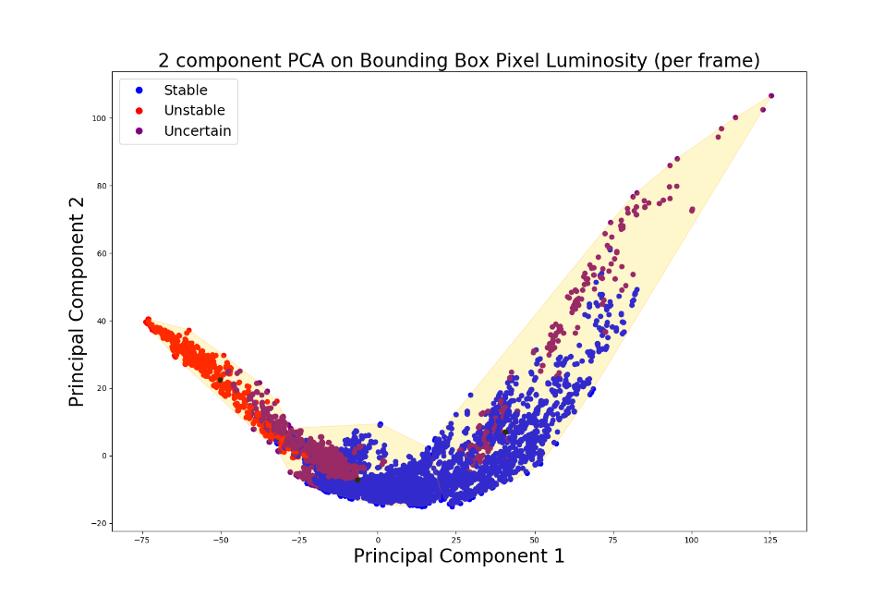

* 1. Supervised Machine Learning

Object detection and image classification is becoming an ever-more-prevalent technique used in the realm of artificial intelligence and computer vision. It can be used to identify (in ream time) features or objects given a still frame or video feed. Thus, I conjectured that it can be an effective way of determining stable and unstable flame conditions given a video.

To do this, I used TensorFlow’s RCNN Inception V2 model. The algorithm receives an input image then proceeds to extract several regions from it and use those regions as inputs for a convolutional neural network, which then extracts features from those regions and tries to classify them into categories that are pre-specified by a user. The classification process itself is done through a support vector machine. To train the model, I incrementally sampled all of the video frames (saving 1 frame in every 30) and labeled all of the features (pilot flame, unstable or stable flame state, and burner cap) I found in each of the chosen frames. This resulted in a set of approximately 570 images, twenty percent of which were allotted to a test set (used to assess the performance of our model) and the rest of which were given to the training set (which is used to modify the weights used in the algorithm to predict the eventual classification). The model trained for about thirteen hours before it was given unseen footage to classify:

The model seemed to pick up stable and unstable flame states pretty accurately; the percentage labels in each bounding box represent confidences that the features detected are indeed accurately labeled. Additionally, I modified the code so that the warning of “Unstable flame state detected!” appeared in the terminal every time a frame contains an image of an unstable flame. 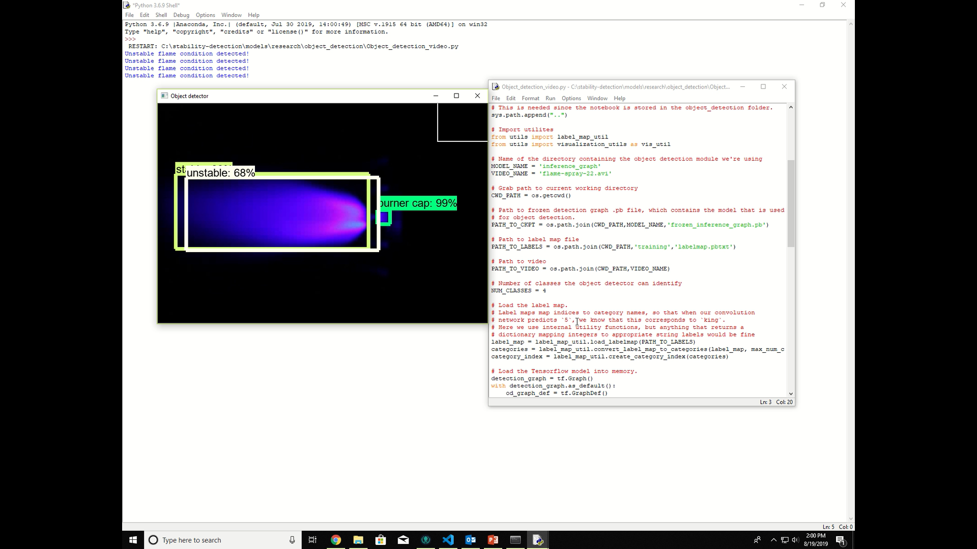

1. Future Steps

Further progress can certainly be made to this research. The current model used for object detection is slow and there is a noticeable lag; using a different object detector such as the YOLO (You Only Look Once) model could provide a much faster means of identifying features in a video, as the suggested model would scan a frame of a video only once to classify the images found within.

Moreover, rather than just alert researchers of unstable flame conditions, achieving autonomous correction of the parameters of the flame to revert back to a stable flame state is a reach goal of this project. This would mean that a researcher could leave the flame unattended for longer periods of time, as the program can simply stabilize the burner flame without the need for human intervention.

1. Conclusion

Using a bounding box to detect luminance fluctuations near the nozzle of a burner flame, it is possible to quantitatively determine flame stability given video feed and use it to classify flame spray pyrolysis footage and images for use in machine learning. Applying principal component analysis for two principal components was able to isolate clusters of points determined to be unstable videos; feeding the algorithm additional points (in the forms of individual frames) and assigning them to the nearest cluster would provide a near-real-time means of generating stability classifications for those frames. Additionally, it is possible to train an object detection classifier for the purpose of recognizing and labeling features in videos of flame spray pyrolysis, and a warning can be sent to a user should the flame reach an unstable state.

**Contributions Made to Research Project**

As a student whose background is rooted firmly in computer science, I at first found myself a little out of place in Marius’s research group. As physicists and chemists and materials engineers, their understanding of the properties of matter and its interactions is far beyond mine. Thus, their manner of approaching the project (of finding real-time optimizations of flame spray pyrolysis using machine learning) is far out of my area of expertise and not something I could make significant contributions to the project with. Therefore, I had to come up with an out-of-the-box method of solving the problem the rest of the team has been approaching for months (and usually from a physics standpoint).

Using image processing and computer vision to approach the problem was a cohesive combination of my own skills and a path that the team had not yet explored; using video footage of flame spray pyrolysis to autonomously characterize its stability was an uncertain prospect, and I was able to explore it fairly well in the past ten weeks. In particular, I was able to determine manners of quantitatively capturing the stability of a flame given several video clips of it. Those classifications could then be used to determine the efficacy or train unsupervised or supervised learning algorithms, respectively. In the end, I was able to train an object detection model to warn researchers of unstable flame states in near-real-time given video or webcam feed. These results were presented to researchers across Argonne National Laboratory in a 30-minute-long seminar.

**New Skills and Knowledge**

Thanks to the support and guidance I received throughout the course of this internship, I am now able to program comfortably in Python and make use of the vast array of libraries that it has to offer, whereas before I only had a shallow grasp of the language. The workflow I was able to develop in a professional setting is also something I will remember for the rest of my career.

Most importantly, when I came to Argonne National Laboratory, I was completely new to machine learning or artificial intelligence. In the course of ten weeks, I was able to apply a wide multitude of machine learning techniques to the computer vision problem I was tasked with solving. The successful outcome is something that far exceeded my expectations and I found this experience incredibly fulfilling as a result of all I was able to learn and accomplish.

**Research Experience on Academic and Career Planning**

I was truly privileged to have been able to learn about and apply  machine learning and artificial intelligence in the world-class setting Argonne offers, with advanced technology and highly skilled researchers to guide me. This experience has solidified my determination to pursue a Robotics and Intelligent Systems certificate at Princeton and take more machine learning / neural networks courses, as well as apply what I learned here to jobs (hopefully revolving around augmented / virtual reality, game development, or robotics)  in the future.

**Relevance to AMO and EERE Mission**

This project’s objective is to minimize the amount of resources and time wasted by generating unstable flame states which do not produce a good yield of target particles. Thus, it contributes to the EERE Advanced Manufacturing Office initiative of efficient energy management by helping to lower the energy cost and waste production of processes such as flame spray pyrolysis. Real-time optimization of manufacturing methods can also greatly boost productivity and even eventually perform better than humans, so research in this area has the potential to greatly improve the production of resources including, but not limited to, energy.

**Acknowledgements**

I would like to extend my deep gratitude to all the people who have made this wonderful research experience possible.

Thank you to Marius Stan for being a wonderful and welcoming mentor who I can count on for guidance, support, and constructive criticism, and to Noah Paulson for being my honorary second mentor who have provided so much valuable insight into my project. I also appreciate Debolina Dasgupta and Joe Libera for helping me collect the needed data, acquainting me with flame spray pyrolysis and flame stability conditions, as well as offer their opinions on paths I can explore when approaching my problem. Additional thanks to Dante Gil-Marin, my fellow intern working to solve the same problem I was working on, for keeping the office lively and contributing to some machine learning banter.

I am so grateful to the EERE Robotics Program, ORISE and Argonne National Laboratory with providing me with this amazing internship opportunity and allowing me to further develop my skills and career.

Last but not least, I am so thankful for the other Argonne employees and students who have toured me around the lab and inspired me to learn and improve myself even more.

**References**